Chapter 4 – What do I need to know?

- I can demonstrate knowledge of the behaviour of waves.
  - What are waves? What are the characteristics of waves?
  - Explain and/or label wavelength, amplitude, and frequency
  - Describe two ways that a wave can travel through a medium

- I can explain the properties of visible light.
  - Explain the wave model of light
  - Compare the behavior of waves to the behavior of light
  - Describe how/why refracting white light creates a rainbow
  - Describe different colours in terms of their wavelength, frequency, energy

- I can compare visible light to other types of electromagnetic radiation
  - Compare the electromagnetic waves in terms of wavelength, frequency, and energy.
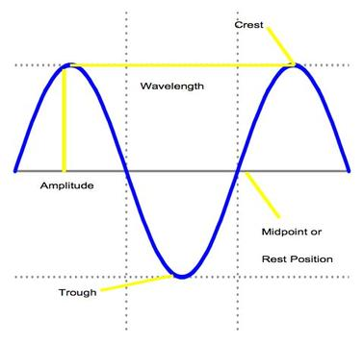
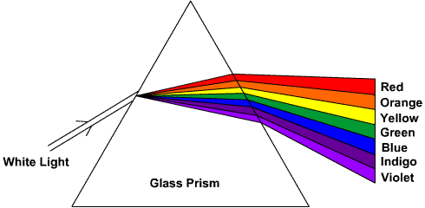
  - What can each of the electromagnetic waves be used for? Where do you come across them in your life?

