Element Infographic
You will be creating an infographic of an element. Please choose from elements #1-20 as these are the elements you will be required to know this year. This is due March 29th – your first day back after Spring Break!!! Remember, infographics arrange information to it is organized, easy to read and broken into SMALL PIECES OF INFORMATION. They are also very visual. Feel free to complete using a computer program or by hand on paper.

You must include:
General Information
A couple interesting facts (When discovered, where found etc., name info)
Symbol
Classification (Non-metal, metal, family, group etc)
Atomic #
#'s of subatomic particles
Common Uses
Common Compounds
Picture (physical appearance)
Mass Number
Ion charge

Models/Diagrams (at least 1 Bohr and 1 Lewis)
Atom
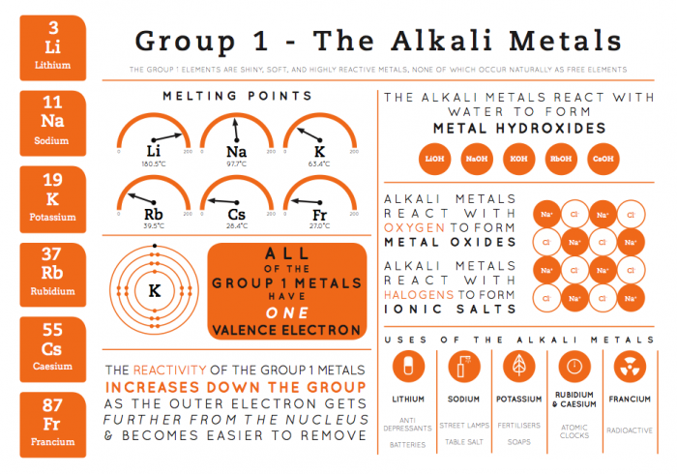
Ion
Compound

Example of an infographic --
This one is for a whole group. You
only need to do ONE ELEMENT.

